**Name Imisi Raphael Aiyetan**

**Course: Econometrics 512 (Homework 3)**

**Impact of Human Capital Development and Capital Accumulation on Economic Growth: Evidence from OLS and IV Regression Analysis**

**Problem 1**

**Question 1a:**

The estimated results on the impact of capital accumulation and human capital development on economic growth are reported in Table 2. Based on t-statistics and standard error, the result shows that both human capital development captured as labor in our model and capital accumulation captured by capital are highly statistically significant. Specifically, a 1% increase in both capital and labor will lead to 52% and 47% increase in output respectively. Finally, the R-squared shows that 96% variation of the model can be explained by labor and capital.

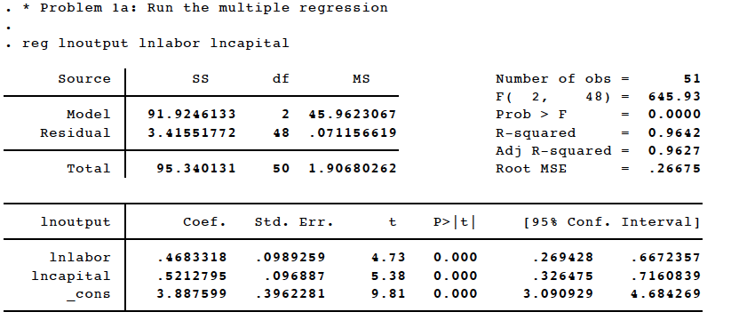**Table 1**: **Multiple Regression Result**

**Question 2a:**

In this section, we carried out a sensitivity analysis by examining the individual impact of capital on output and the impact of capital on labor. The objective here is to see the relationship that exists between the residuals coming from individual’s regression analysis. We interpret the results as follows.

**Case 1: impact of capital on output**

In this subsection, we show that capital has a strong significant impact on output. In particular, a 1% increase in capital will lead to a 96% increase in output. Intuitive, capital is one the factors that derives output growth.

**Case 2: impact of capital on labour**

In this subsection, we show that capital has a strong significant impact on labor. In particular, a 1% increase in capital will lead to a 94% increase in output. Intuitive, capital accumulation is one the factors that derives human capital development.

**Table 2a**: **Simple Regression Result for case 1**

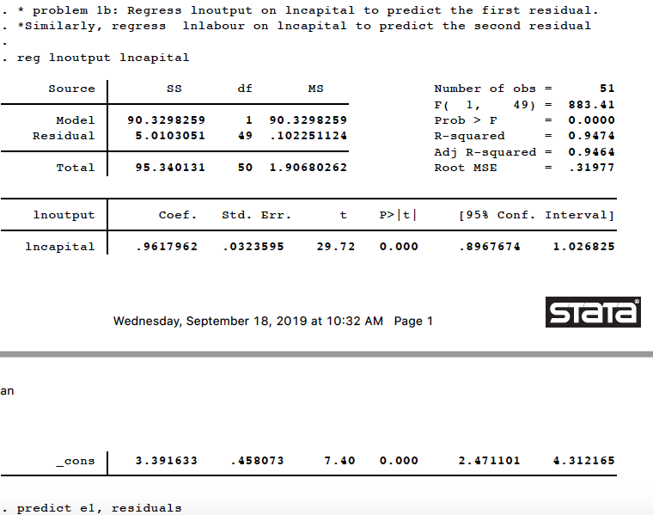

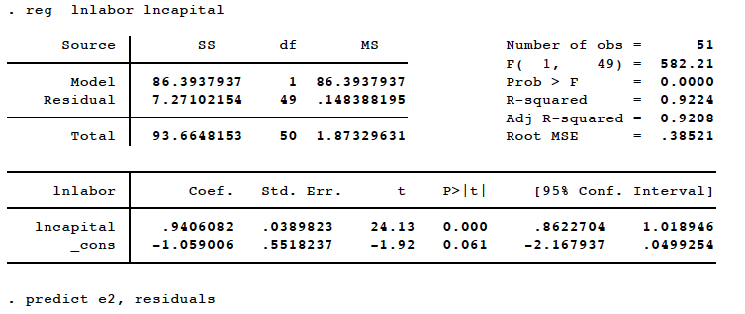**Table 2b**: **Simple Regression Result for case 2**

**Case 3: Impact of innovation 2 (Case 2 residual) on innovation 1 (Case 1 residual)**

In this subsection, we show that the innovation coming from the impact of capital on labor has a strong significant impact on innovation 1. In particular, a 1% increase in innovation 2 will lead to capital will lead to a 46% increase in output. Specifically, the two residuals are closely related.

**Table 2c**: **Simple Regression Result for case 3**

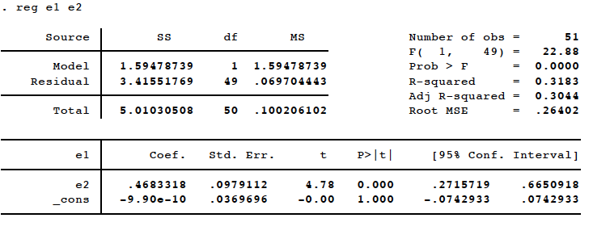

**Question 1c**

In this section, we alternatively test for our result in Question 1b of case 3 to see if we will arrive at the same result. The result that emerges from this analysis shows that using another approach the estimated paraments are the same. *The reason why this occurs is that we examined the innovations (residuals) coming from the impact of capital on labor on output, which is similar to our analysis in Question 1b. However, the result here is insignificant, indicating that the innovation 2 as described in Question 1b does not determine output growth*.

**Table 3**: **Simple Regression Result for impact of innovation 2 on output growth.**

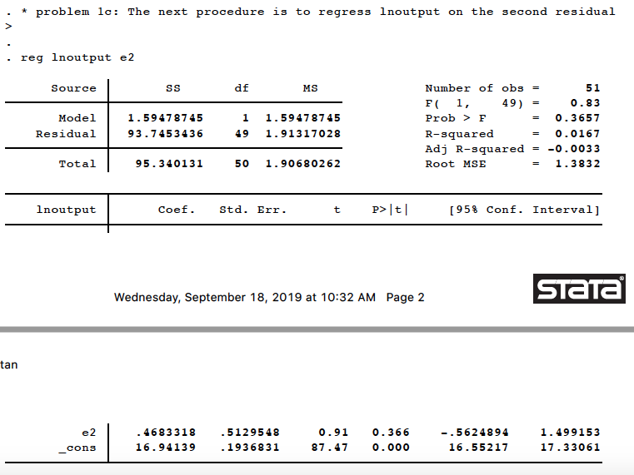

**Note:** The raw results and the **STATA codes** that produced all the results are given in the appendix section of this research paper. Comment on how we implement the econometrics are also given.

**Problem 2**

In this section of the research paper, we assumed that capital accumulation correlated with the residual of the regression model in Question 1a. Therefore, we took a step backward to see how this problem can be solved. In addressing this problem, we carried IV-Regression analysis replacing capital accumulation with a variable that does not correlate with the error term called lnoutlab in this model.

Question 2a

In this section, we examined the impact of capital and labor on output using the Generalized Method of Moment (GMM). The result shows that capital has a strong significant impact on output. The implication is that a 1% increase in capital will lead to a 138% increase in output. However, labor is insignificant in this model suggesting that labor does not drive output growth. As a result of this problem, we proceed to carry out IV-regression using our instrumental variable.

**Table 4a**: **GMM Result**

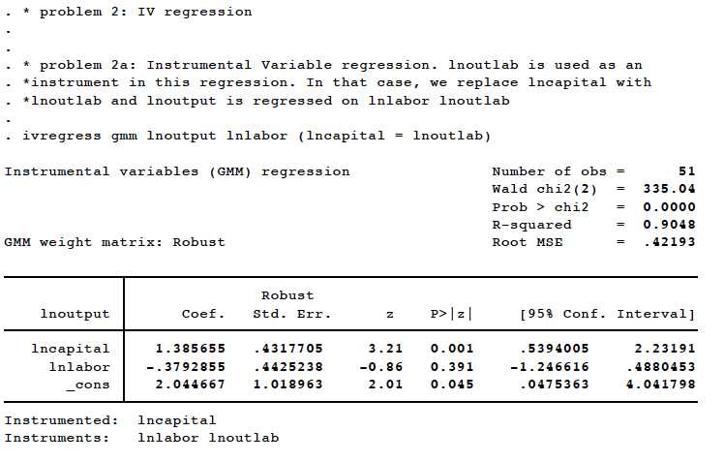

After considering the instrumental variable, the result shows that both labor and the instrumental variable have a highly significant impact on output growth. In particular, a 1% increase in labor and the instrument variable will lead to a 100% increase in output growth. By implication, after introducing the instrumental variable, labor has a full impact on output. Furthermore, we predict a new variable from this estimation to see if two-stage will support our result.

**Table 4a**: **IV-Regression Result**

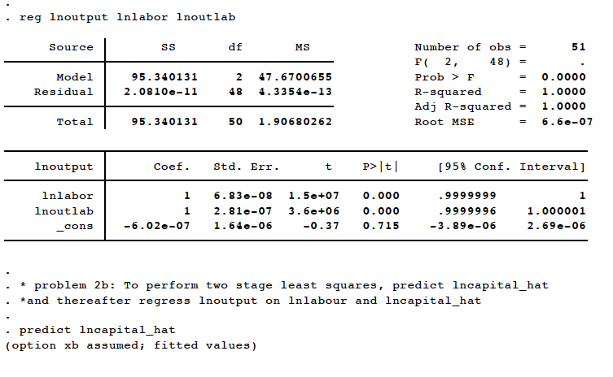

**Question 2b:**

In this section, we examined the impact of labor and the predicted variable on output. The result indicates that the predicted variable has a great impact on output growth using two stages least square. On the other hand, labor is insignificant to the model. However, IV-regression result is more robust compares to two staged-least squares

**Table 5**: **Staged Least square Result**

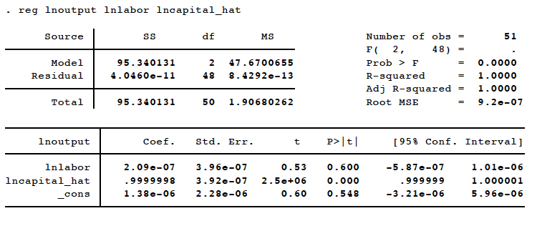

**Question 2c:**

In this section, we carried out a reduced form regression to see the ratio of the impact of labor and the instrumental variable on output to the impact of labor and the instrumental variable on capital. The results of the two regression are robust, hence, the predictive power the coefficient is high.

**Table 6a**: **Reduced form 1 regression Result**

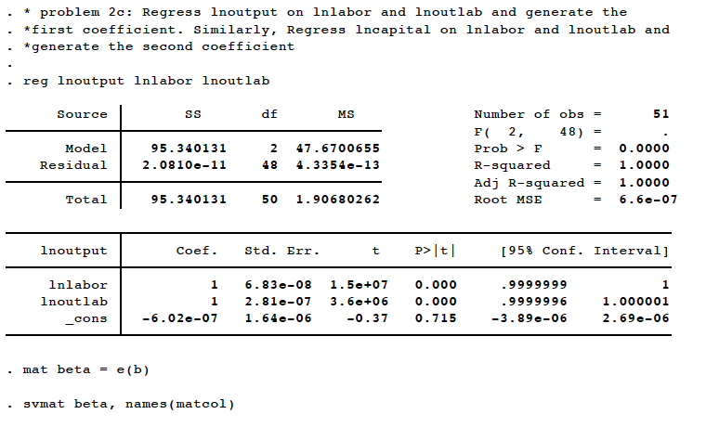

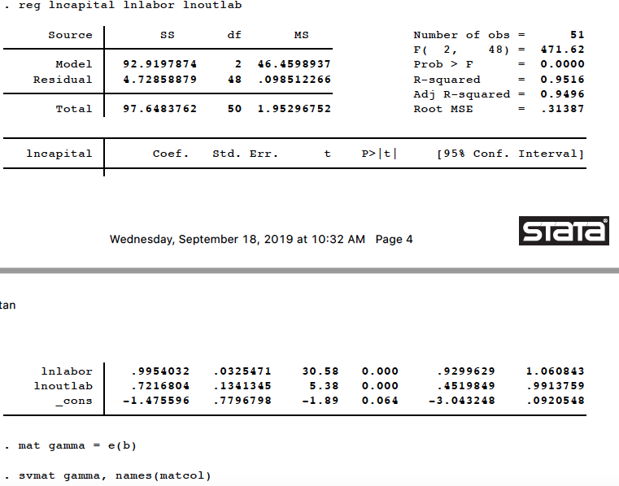**Table 6b**: **Reduced form 2 regression Result**

**Table 6c**: **Ratio of the two** **Reduced form regression Result**

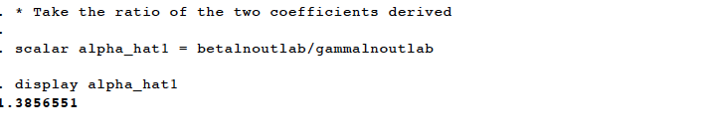

**Question 2d**

In this section, we check using a different approach if we are going to arrive at the ratio of the reduced form regression model, we estimated in Question 2c. The results from this analysis are fairly robust and give the ratio of the reduced form regression.

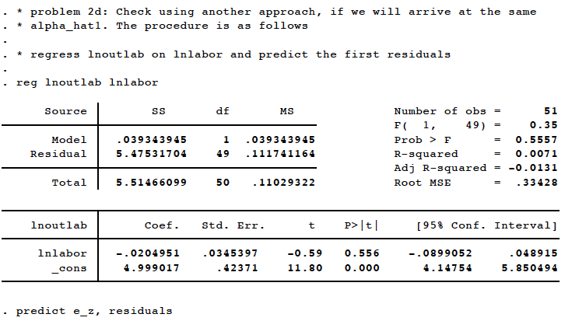**Table 7a**: **Simple Regression Result 1**

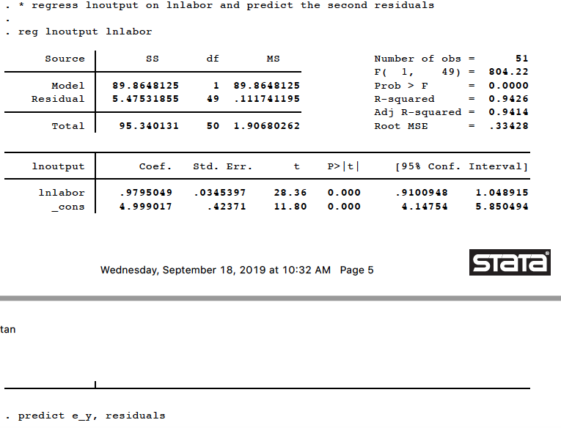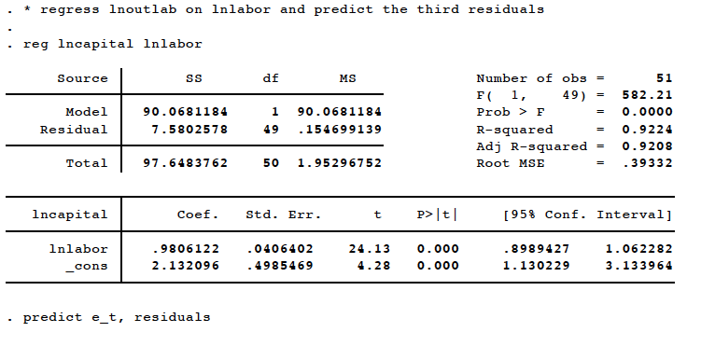**Table 7b**: **Simple Regression Result 2**

**Table 7c**: **Simple Regression Result 3**

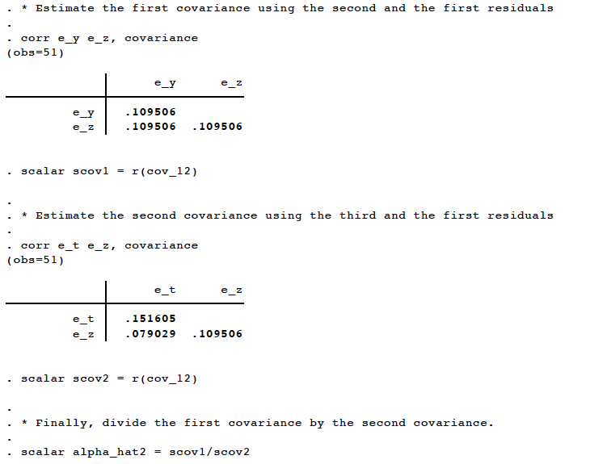**Table 7c**: **Covariance Results from the Residuals of the three Regression result**

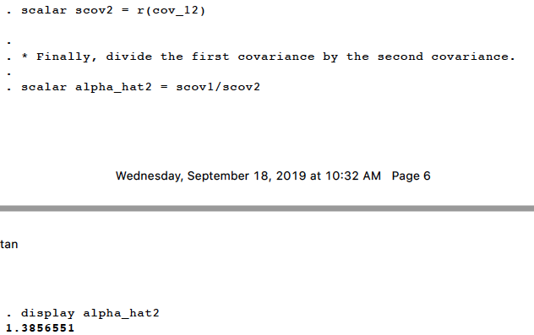**Table 7d**: **Ratio of the two Covariance Result**

**Note:** The raw results and the **STATA codes** that produced all the results are given in the appendix section of this research paper. Comment on how we implement the econometrics are also given.